**In APRIMA Go to List Editor 🡪Demographics 🡪 Insurance Payer**

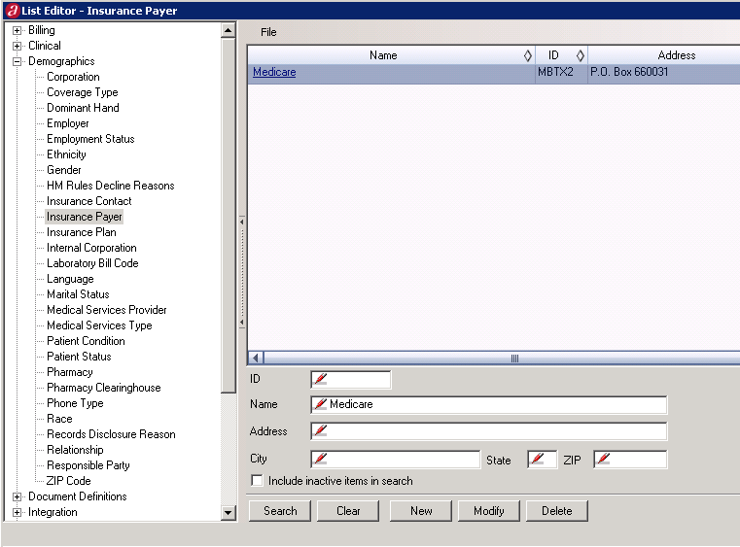

Using Medicare as a TEST Example

Search for Medicare by typing Medicare in the Name field and Click on the Search Button

Click on “**Medicare**” and Go to the **SETTINGS** Tab

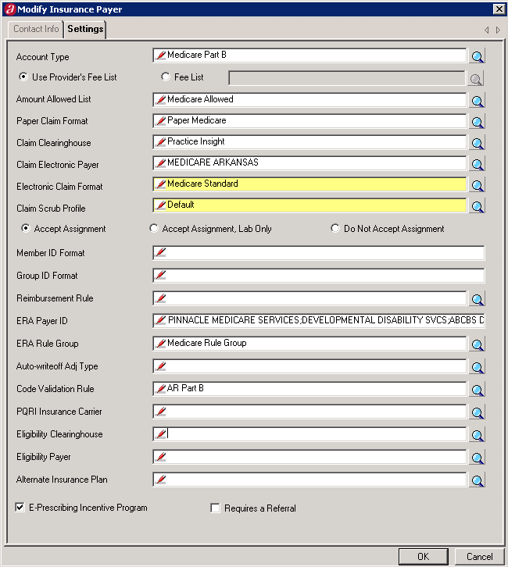

Go to **Eligibility Clearinghouse** and either type in “Pr” and tab or click on the Magnifying Glass; click on search (if you need to) and select **Practice Insight Eligibility**.

Go to **Eligibility Payer** click on the Magnifying Glass

* Click “**New**”

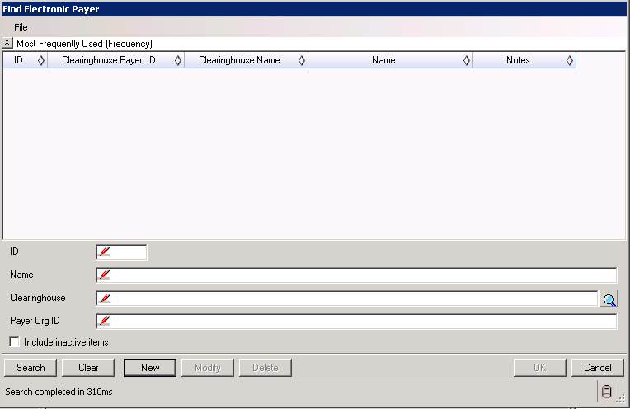

* **The New Electronic Payer window will display.**

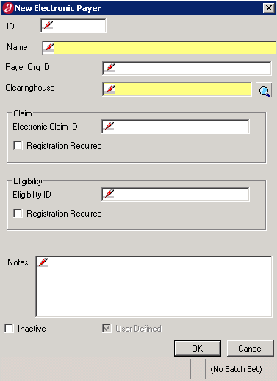

* Look at the Practice Insight Payer List and look for the Insurance Carrier (i.e. this one is AZ Medicare)
* The payer lists has “MBAZ2” as the Payer ID for MEDICARE ARIZONA



* In the **NAME field**; put in MEDICARE ARIZONA
* In the **ID**; **Payer Org ID**; and ELIGIBILITY – **Eligibility ID**; PUT IN MBAZ2 (or the insurance payer ID)
* Make sure **not to put anything** in the **Electronic Claim ID** in the Claim section; this **MUST be BLANK**
* In the **Clearinghouse field**; click on the Magnifying Glass and select **Practice Insight Eligibility**

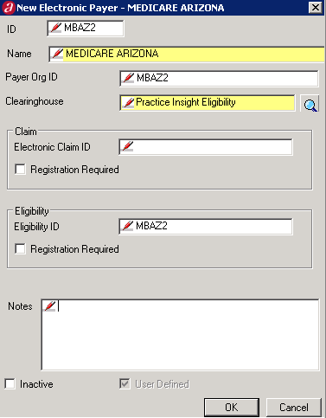

* Click OK and you are done.

**\*\*NOTE: Look for your states Medicare for your practice that you are setting up, etc … THIS IS JUST AN EXAMPLE.**

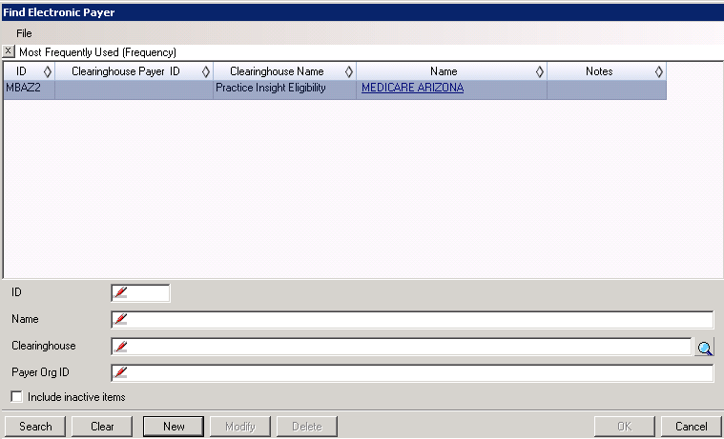

* Click on the MEDICARE ARIZONA **hyperlink** and you are done.
* This is what it should look like after you are finished completing the Eligibility Clearinghouse linking to the insurance payer.

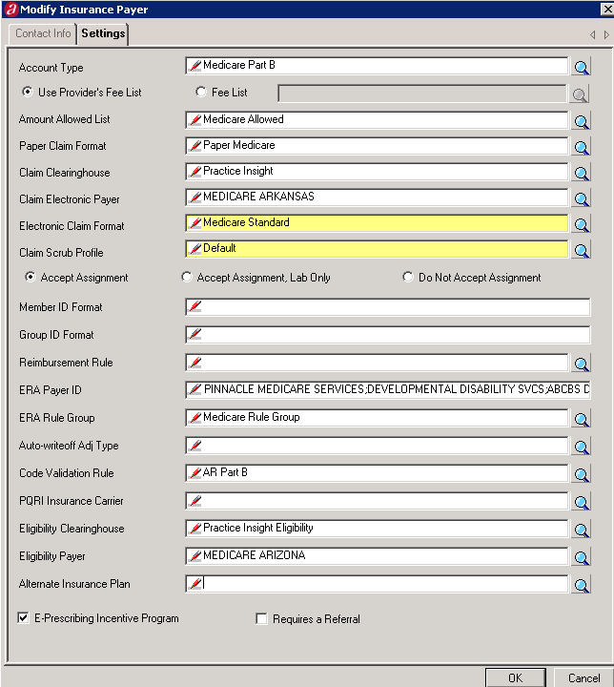

* CLICK OK.

**Do this step for all the Insurance Payers’ in APRIMA that are listed in the Practice Insight Payer List. If you wish, you can have the billers in the practice do this step, but please make sure that they understand how to input the information in those two fields.**